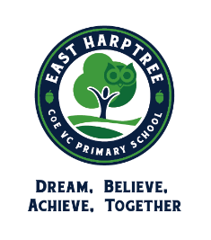

Whole school panto trip Tuesday 14th December December 2021 to see Snow White at Bristol Hippodrome.

Tickets are kindly paid for by PTA funds and ice creams are sponsored by Sam Watson at Valentino's Kitchen!

Please can parents log onto ParentPay and give consent for their child to go on the trip. We would greatly appreciate a voluntary contribution of £6.00 per child towards transport costs via ParentPay too.

ALL children to bring in a water bottle and packed lunch from home or book an Aspens sandwich on this date to ensure children can have early lunch and get to the performance on time. Please complete payment, consent, contact and medical info.

We are also looking for a number of parent helpers to come along. You would need to be available from approximately 12.15 to 6pm. Please let us know if you are available.

(We anticipate arriving back at school between 5.30pm and 6pm.)

Thank you.

I give consent for __________________________________________________ to go on the pantomime trip Tuesday 14th December 2021

Please give details of any medical conditions or dietary requirements

__________________________________________________________________________________

__________________________________________________________________________________

__________________________________________________________________________________

