B&NES Child and Family Health Service
School Aged Health
Kempthorne House
St. Martin’s Hospital
Clara Cross Lane
Bath BA2 5RP

t: 0300 247 0055
Opening Hours 9 am – 5 pm Monday – Friday
e. hcrg.bathnesspa@nhs.net
w: www.bathneshealthandcare.nhs.uk/services

Date: As per email
Dear Parent or Carer

Measuring height and weight of children in Reception and Year 6

Every year in England, school children in Reception and Year 6 have their height and weight measured at school as part of the National Child Measurement Programme (NCMP); Your child’s class will take part in this year’s programme

You can watch the NCMP process animation.

The animation explains the process of the NCMP and why it is important. It will guide you through what it involves, how your child’s data is collected and processed and what it will be used for.
National Childhood Measurement Programme process

 | Parent/Carers are notified
- A letter will be sent via email
- Letters are sent to Year 6 in term 1 and Reception in terms 2 and 3
- If you do not wish for your child to be measured, contact the School Aged Health Service as by emailing bathNES.NCMP@hcrgcaregroup.com or in writing to the address above within 2 weeks of receiving this letter.
 | What do I need to do?
- Discuss measurement day with your child
- Share the process animation with them so they know what to expect
- Children will not be made to take part on the day if they do not want to
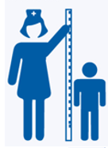 | Measurement day | 
- Children are measured in a private space
- Only coats and shoes are removed
- A trained member of the School Aged Health Service takes the measurements
- The measurements are confidential, and not shared with your child or the school
 | What feedback will I get? | 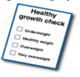
- A letter will be sent home addressed to you with your child’s height and weight results
- You can use the tools provided to check your child’s weight category
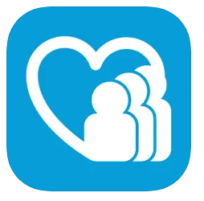 | What can I do to support my child?
- Visit the ‘your child’s weight’ page at Healthier Families for tips about establishing healthy eating habits for the future
- Contact the School Aged Health Service on 0300 247 0055 or your GP to discuss the results
- You may receive a follow up call from the School Aged Health Service to discuss your child’s results and offer support and advice
- Download the B&NES Child and Family Health App from the App store or Google to access resources and information relating to your child’s health and well being

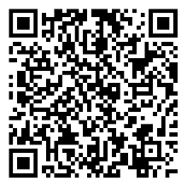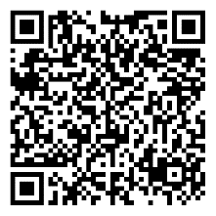
Information and fun ideas to help maintain a balanced diet and physical activity for your family can be found by visiting:
NHS Better Health: healthier families webpage: Easy ways to eat well and move more
NHS Healthy Steps email programme with lots of low-cost easy tips, fun games, healthy swaps and tasty recipes on a budget: Healthy Steps - step this way

You can read more about how B&NES Council and HCRG stores and uses your child’s information at:

- HCRG Care Group – NCMP Privacy Notice
- B&NES Council – B&NES Privacy Notice

If you have any concerns regarding the processing of your data, please contact the National Child Measurement Programme team on 01872 322828.

Yours faithfully

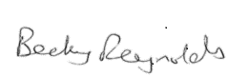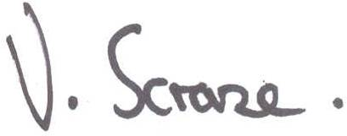

Becky Reynolds Val Scrase
Director of Public Health & Prevention Regional Director
Bath and North East Somerset Council HCRG Care Group
BSW Community Health Services

