EAST HARPTREE  CHURCH  OF ENGLAND PRIMARY SCHOOL | 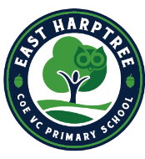 |   UBLEY CHURCH OF ENGLAND PRIMARY SCHOOL

29th September 2025

Dear Parent/Guardian

Wells Festival of Literature: Thursday 23rd October

Organisers of the Wells Festival of Literature have invited Year 5 and 6 to hear the author, Sam Sedgeman https://samsedgman.com/ He will talk about his life as an author and his new book The Forbidden Atlas.
This event will take place on Thursday 23th October at Cedars Hall, Wells. Children will have an early lunch at 11.30am at school and then depart at 12 noon. Please can you send them with a packed lunch or book a cold sandwich option on Aspens Select for this day so that they can eat early on this day. We are very grateful to Wells Festival of Literature for fully funding the transport and the event.
The PTA have generously offered to buy each child a copy of the author’s book and some additional copies to be kept at school in the library.
Please can you log into parentpay.com to give your child consent to go on this trip before Tuesday 21st October.
Yours sincerely,
Mrs Tomblin and Miss Collins

